SPEAKER PROFILE

Jeanette McMurtry, MBA

Speaker Biography
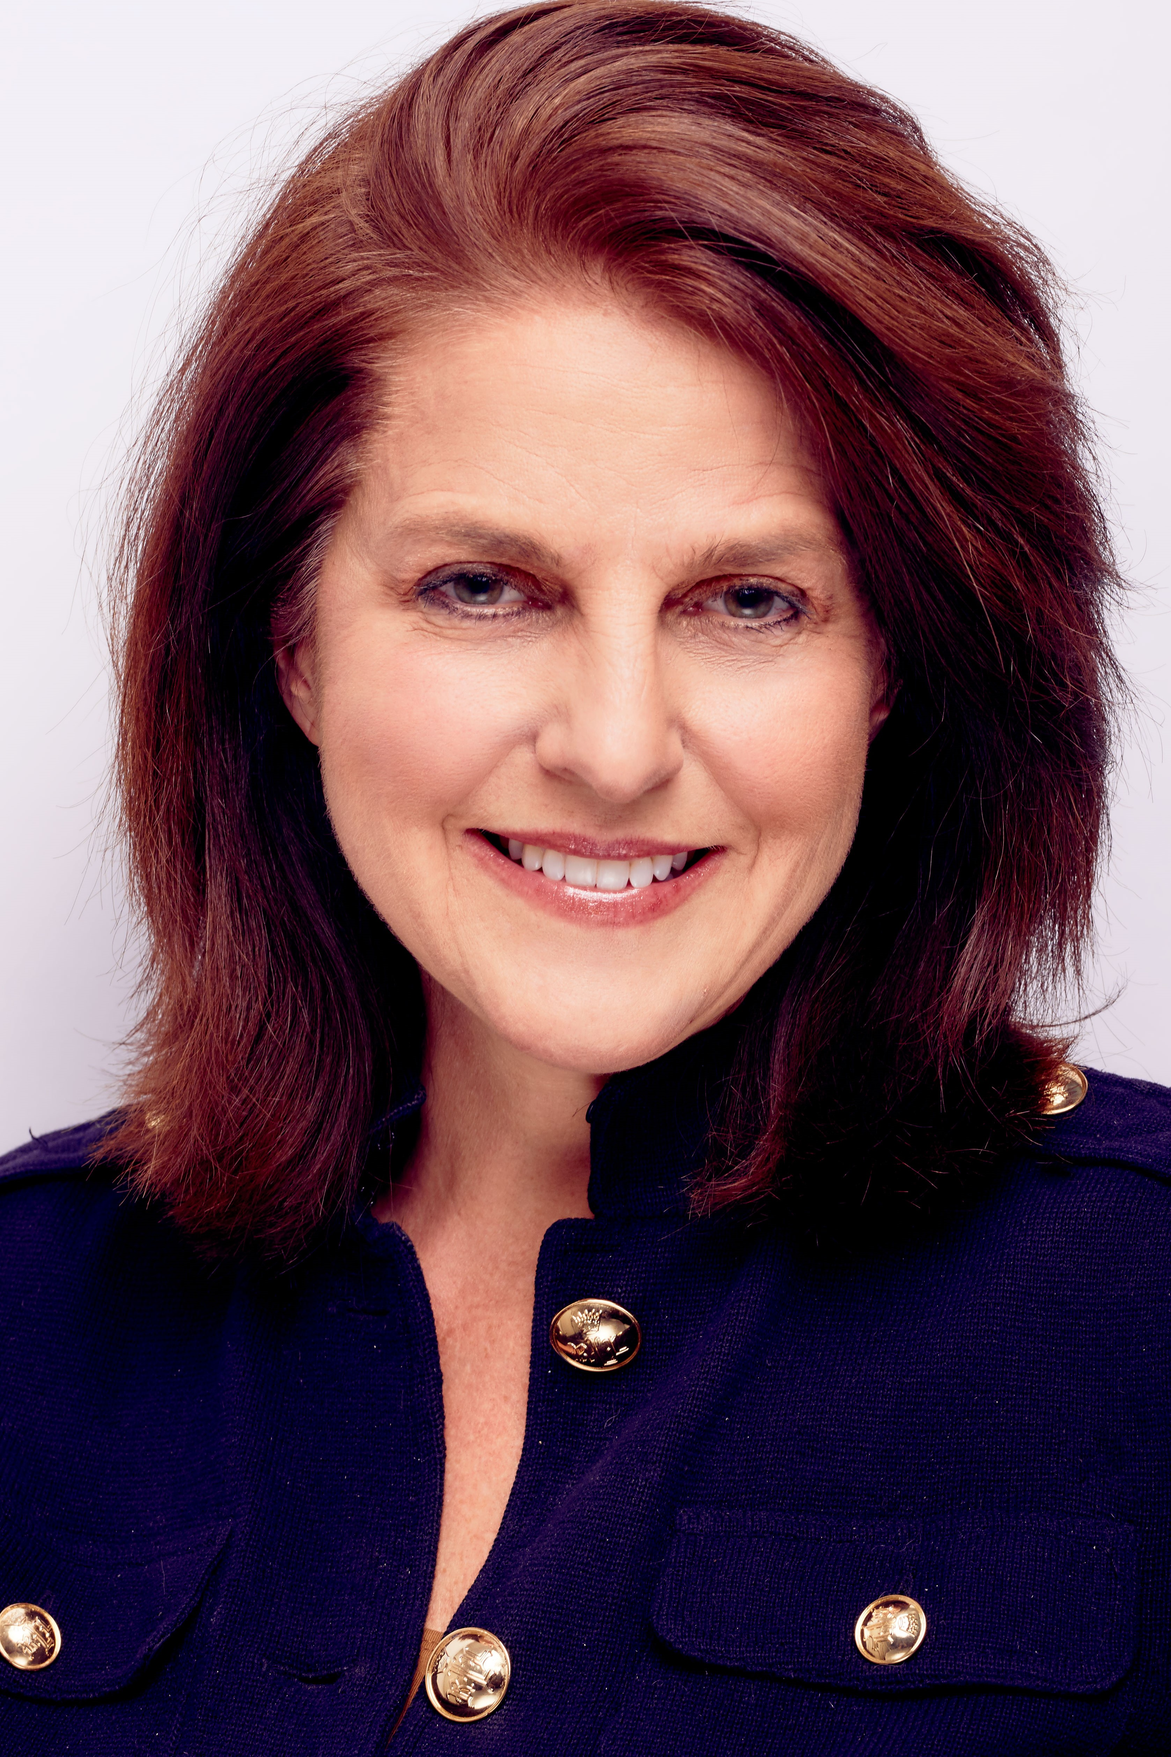
Jeanette McMurtry, MBA, has been a keynote presenter and author on how to trigger the unconscious mind for unthinkable ROI at events across the US, Asia, Europe, and Central America. Her approach to psychology-based marketing has been helping organizations, brands, and companies like the Direct Marketing Association, Sony, Travelers, Xerox, HCA/HealthOne increase engagement, sales and revenues by 200 – 500%, and more.

Jeanette is the author of “Marketing for Dummies,” Wiley 2017 - Fifth Edition, and “Big Business Marketing for Small Business Budgets” McGraw-Hill. She has been a monthly marketing columnist for national publication for more than 15 years. Currently, she is the Principal of e4marketing, a consultancy and training organization providing organizations and companies with strategic and tactical support for marketing, branding and customer engagement programs. She is a back by popular demand keynote speaker for global events, speaking in major cities such as Shanghai, Sydney, Singapore, Santiago, San Francisco and many more.

Links to Speaking Example and Social Media Pages

