Bonnie Silva, Director, Office of Community Living, bonnie.silva@state.co.us
Bonnie Silva is the Director of the Office of Community Living and serves the role of guiding policy, strategy and system redesign. The Office of Community Living administers long-term services and supports benefits for people with physical, intellectual and developmental disabilities. This includes long-term services and supports for people living in their home and community to services provided by nursing facilities. Bonnie has extensive experience in program administration, policy development, quality oversight and community engagement.
Bonnie has worked on disability policy in both the government and non-profit sectors, holding positions with service provider agencies, casement management agencies and state departments. She has also worked as a direct support professional for people with disabilities and in leadership positions providing oversight and direction for disability programs across the state. Prior to her current role, Bonnie was the long-term services and support Division Director at the Department and has extensive experience in program administration, policy development, quality oversight and community engagement.
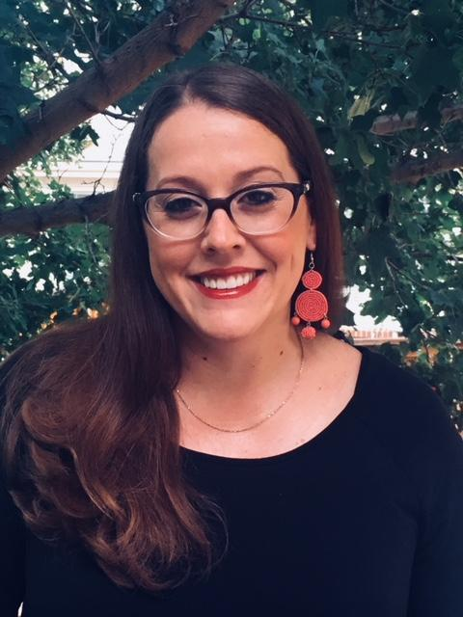

Colin Laughlin, Deputy Office Director and Benefits and Services Management Division Director, Office of Community Living, colin.laughlin@state.co.us
Colin Laughlin is the Deputy Director of the Office of Community Living and Division Director over the Benefits and Services Management Division at the Department of Health Care Policy and Financing. He has been in this position since 2017. The Office of Community Living administers all long-term care programs within Colorado Medicaid. The work Colin focuses on in addition to his Deputy role is to promote effective and efficiently delivered services and supports across a spectrum of care that is easily and equally accessible to all Coloradans in a way that promotes dignity and independence through choice.
The services, benefits, and programs he is responsible for serve over 75,000 individuals with intellectual and developmental disabilities, physical disabilities, aging and older adult associated conditions, and more. He has been with the Department of Health Care Policy and Financing for eight years. Prior to his work at Medicaid he worked at the Denver Metro Chamber of Commerce and in a variety of political positions in Minnesota. Colin holds dual Bachelor degrees in Political science and History as well as a Master’s in Public Administration. Colin lives in Denver with his wife and two dogs.

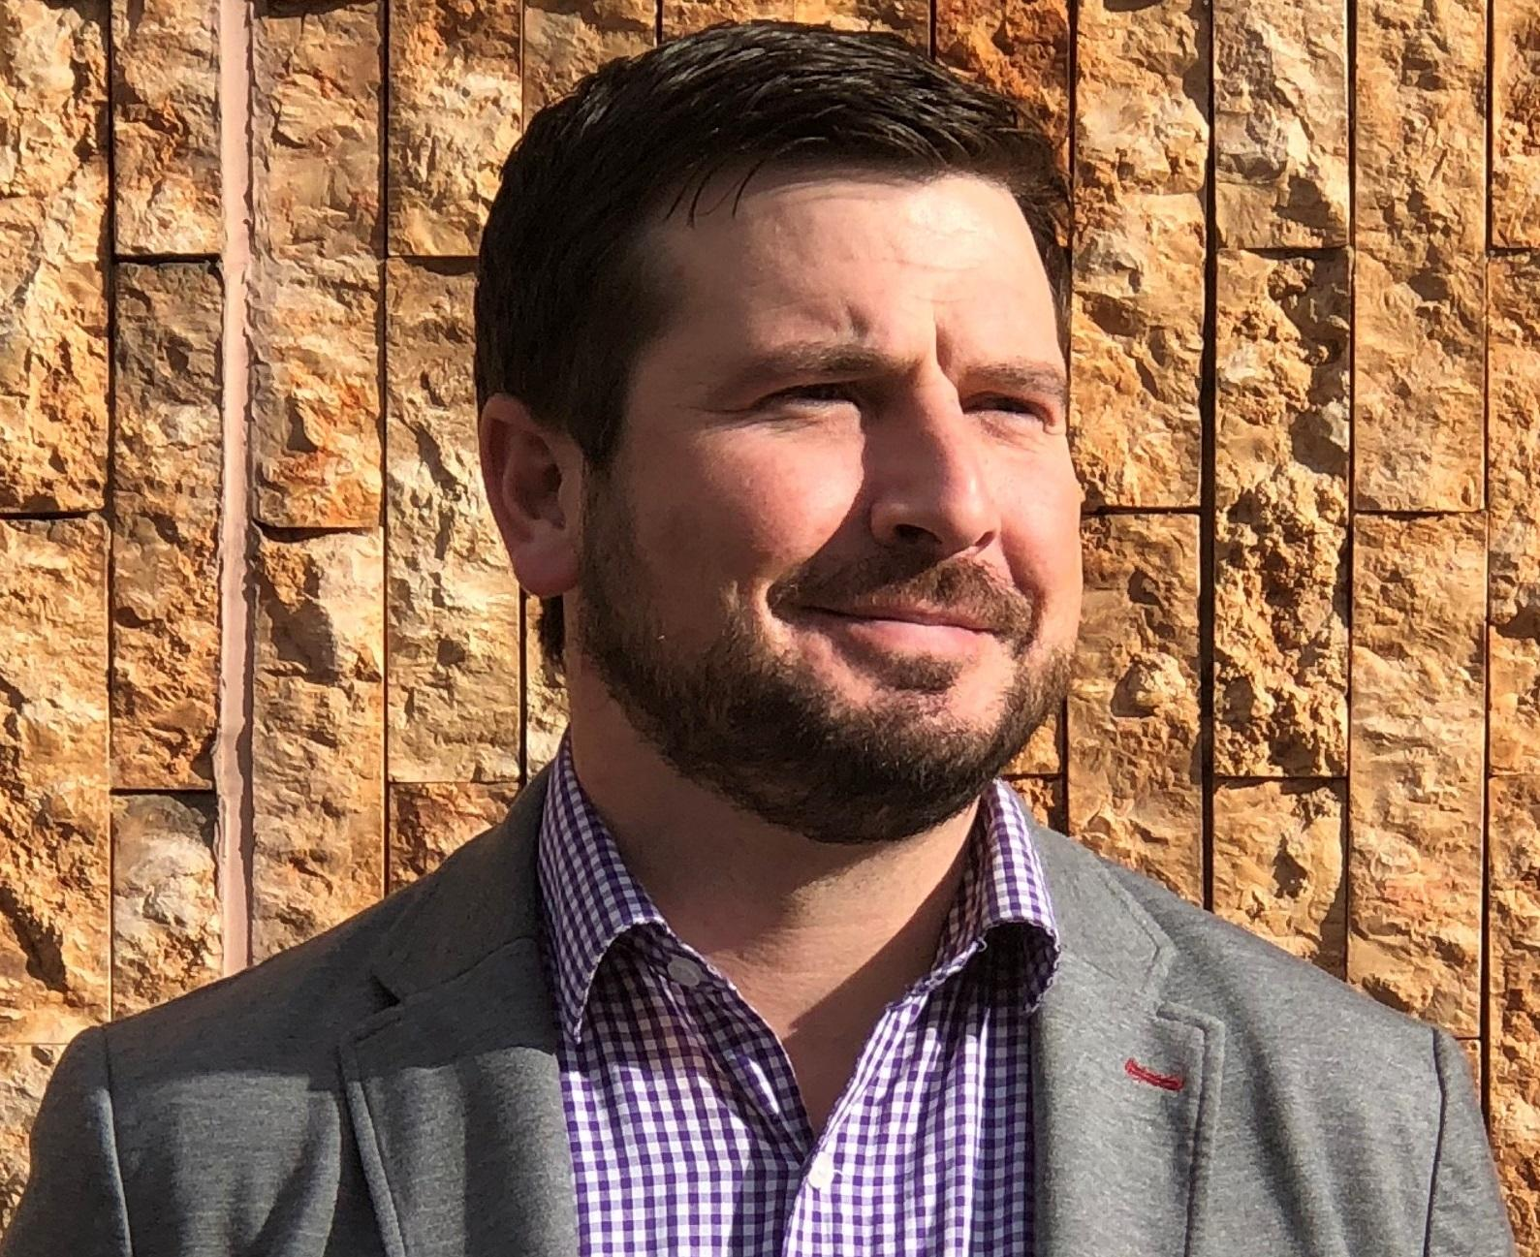
Amanda Lofgren, Case Management and Quality Performance Division Director, Office of Community Living amanda.lofgren@state.co.us
Amanda Lofgren joined the Department of Health Care Policy and Financing in August 2019 and in February 2020 moved into the role of leading the team overseeing the Case Management and Quality Performance aspects for Colorado's home and community-based services. Prior to her work with the Department, Amanda lived and worked in Alaska for approximately 12 years in the health and human services field, including 5 years with the State of Alaska; Department of Health and Social Services. In this work, Amanda developed expertise and had successes in collaborating with stakeholders on numerous LTSS systems change efforts, including Case Management Redesign and Conflict-Free Case Management.
While in Alaska, Amanda also worked for 5 years as a Program Officer at the Alaska Mental Health Trust Authority. Her work there included, among other things, collaborative work with Alaskan tribes and a focus on Long Term Services and Supports. She was also a part of the state leadership team overseeing the development and implementation of Medicaid Reform and Expansion. Amanda holds a graduate degree in Human Development and Family Studies and undergraduate degree in Gerontology and has a strong passion for working to ensure individuals and their families have access to home and community-based services. Amanda lives in the Littleton area with her husband Bryant and their two children; Hans and Haddi and dogs; Duke and Dozer, and enjoys the CO outdoor activities, weather and year round sunshine!

