Yes I Can……. Learn to use technology!!!!

What is the Carrot??? As we are preparing individuals to utilize technology for in their lives… what is the motivation to use!!!
Independent living Self Determination in Community Employment Leisure Socialization

In our situation “Independent Living” was the goal - we needed to do time analysis of how long it took Kara to accomplish activities and to reevaluate frequently to ensure success as we utilized voice reminders.

Then a Trial period … at our house with life in her own house as the end goal.
What is success??? 2 hours to get dressed and get breakfast independently!
Think of the individual’s primary use and purpose for tech and go from there!!
In our life…iPads and apps are my interest -I research and find apps that can be utilized to support these areas
Home Safety Daily Living skills Memory Scheduling Leisure Skills Socialization
Not all devices are created equal… however there are many similarities in all. Accessibility features, home navigation and the ability to easily navigate settings are common.
Options in iDevices… What to Consider
IPod touch starting at $229.00
Storage from 16-64GB has camera/video capability for tasks and modeling and is Wi-Fi capable
The iPod touch or iPhone is a good option for someone who needs a “memory in a pocket”
IPhone – a range of prices and storage and must have a monthly plan for service
or utilize an older one just for tasks with apps without phone capability – they still maintain Wi-Fi capability

iPads starting at $249.00 up to $699.00 or more- all are Wi-Fi capable
Storage range from 16 GB to now over 500GB
iPad mini with 16GB $249.00 to iPad Air 2 at $699.00 or more
new lower cost iPad just released in April 2018
Add speakers… wired or Bluetooth and sturdy case - $100.00

Other very practical, more affordable and useful options….!!!!!
Kindle Fire!!!!!!!! Starts at $49.99 and more and more capabilities being added all the time! You can add storage, has camera and video capability
App choices are more limited…but huge bonus is built in Alexa!!! Alexa is now available hands free on all newer Fire Tablets!! Amazing tech potential for more voice control for users!!! For starting point of $49.99. Limited apps compared to iDevices but great accessibility options built in!
Other Android tablets and Android phones!!!! Google Play is the App Store for Android users and I have a list of some recommended apps and uses attached.
Look at “Native Apps” meaning the Apps that come with your device- to utilize for scheduling and time management – you may not need much more than these
Calendar Reminders Clock/Timer/Alarm Voice Recorder
Other Apps from App store range from Free to $$$$$. There is an ability to set up “shared account” with the Apple App store and share Apps, Calendars, Reminders and a multitude of items!!! Just Google the “How to’s.”

A look at the Native Apps on iPad
Calendar
Remote management with entering events from shared Apple accounts- can set up sounds and alerts on screen for the events of day
Recurring events can be set …like daily weekly or monthly
Can utilize to be reminded at certain intervals before the event
Use SIRI for ease of use
Tell SIRI “Schedule…event, date, time” - double check notifications set
Cloud capability is great

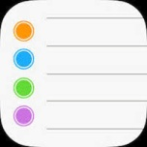 Reminders
Remote management with entering events from shared Apple account -can set up sounds and alerts on screen for the reminders of the day or even place!
Recurring events can be set …like daily weekly or monthly
Use SIRI for ease of use
Tell SIRI “Remind me…event, date, time” - double check notifications set
Cloud capability is great….
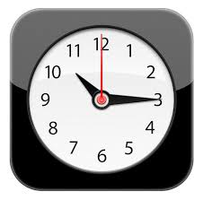Clock can be utilized as a simpler time management tool with sounds and labeled events
Limited as to how far ahead you can set times and use
Voce Memo’s on iPhone…. Good for recording a message or note-can label it and set a time for it to go off. Can send the audio recording to others

If you brought a different device to this Learning Lab… let’s take a look at your choices for “Native Apps”

With all of these you must know how to manage the Apps “Notifications” in Settings… Not difficult as you choose how you want to be “notified” meaning how the app talks to you- about the Reminder, Timer/Clock or Calendar event

Make Settings your friend in whatever device you use! This is where you will find and choose the accessibility options to make the device most functional. I LOVE the larger print!!! Do not be afraid of Settings …you cannot hurt your device by making changes in setting and if you don’t like what the change did- just turn it off to revert to old setting!!!

Purchased Apps...

“Reminder” ….Our favorite purchased reminder app!
We utilize Kara’s own voice or music clips to go off all day long to guide her through her day
Reminders- lets you create reminders very easily and quickly. Recurring reminders are fully supported, and you can set hourly, daily, weekly, monthly and yearly reminders, or even days of the week or month. It also has a wake-up alarm with custom snooze time.”
$1.99 http://www.aidaorganizer.com/mac/index.html

Super useful for use for those who like to check off what they do!
Three different Views
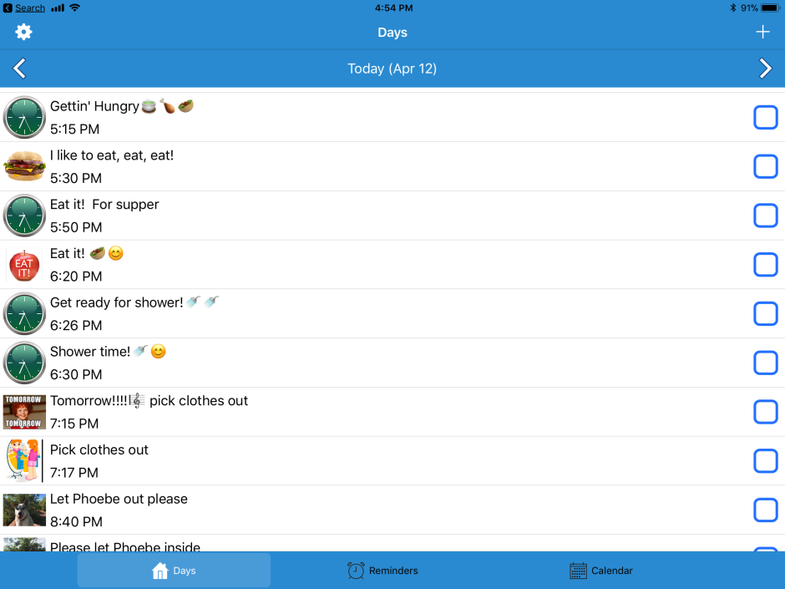
Day’s shows ‘today’s’ reminders

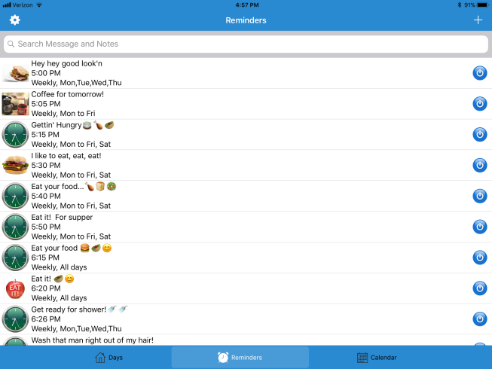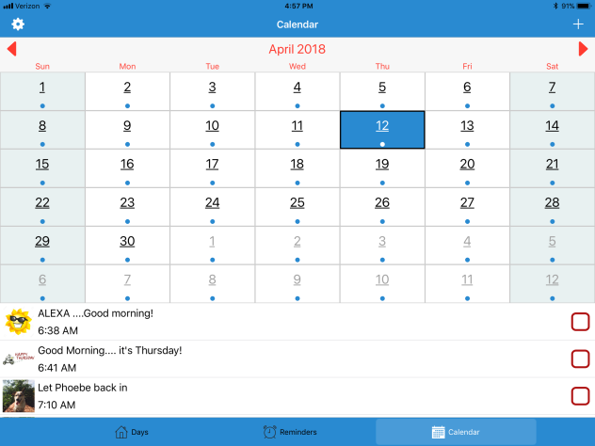
Reminders shows all of the reminders Calendar - Date &Reminders

Ability to send and save backup of all of the reminders by email and to make changes remotely and send back by email – must install back to app but so easy!
Allows users to create voice files, a music files and set up a multitude of prompts, icons, times….Limitless!!
Main Screen Hit the Plus sign to add a Reminder …Chose type of reminder… “Wake up alarm”

Once you choose the type of reminder you need…just go down and enter info into each field. As with any app once you have completed that field remember to “Save” or “Done” or whatever 4 letter word is needed to save the newly added info

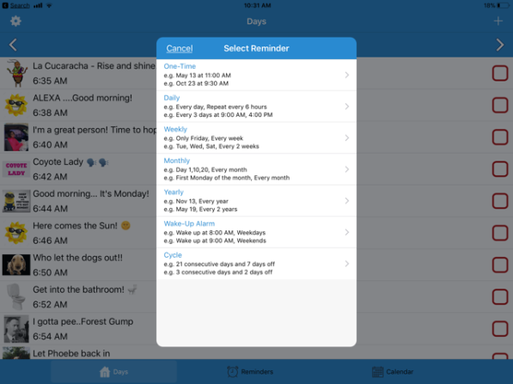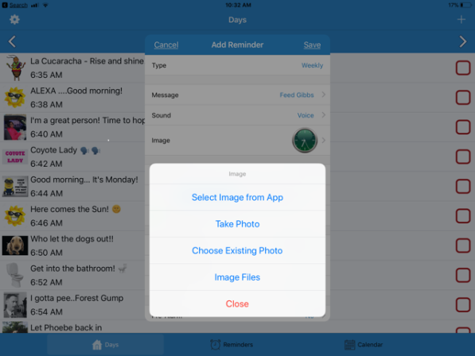
Chose the type of reminder you want… add Icons

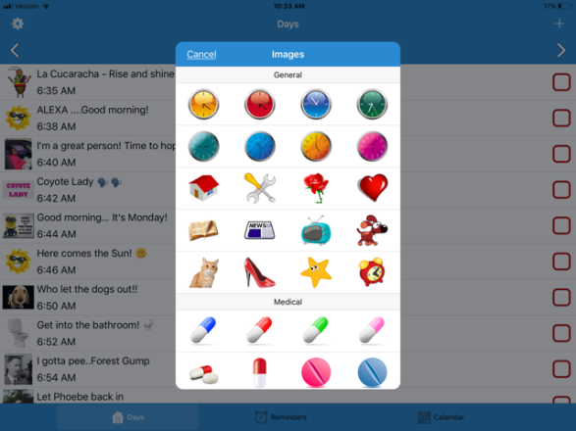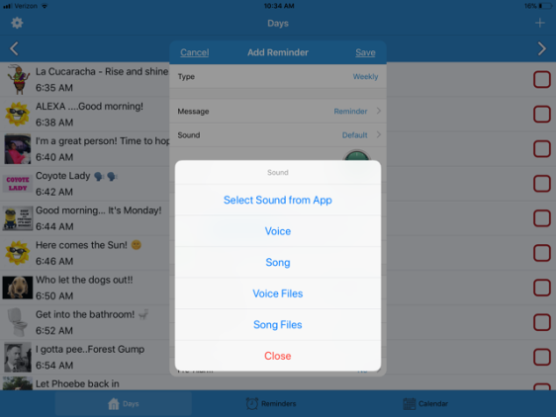
Built in icons/images/pictures or add your own Add Voice or music… create files!
Incredible number of features built in!!! Create voice files, song files to reuse over and over!! Start working your way down the menu and pull in features you want to use!!!
Most important thing is to remember to touch “done” or ‘save” or “next” once your choices are entered
Music Reminders!!!
Use music and create a library of music reminders! Record snippets of songs up to 30 second’s worth- as music can really motivate and be a change from the voice reminders…plus fun!!
You need to have songs or albums in your device music library either purchased from iTunes or transferred from PC to device from iTunes
So functional and useful!!!!
- Can add icons or your own pictures for each prompt
- Add text for readers or support people who can see what is coming up
- Totally customize an individual’s schedule even with changes during days of week
We have set up a range of prompts to organize the week
  - Monday-Thursday
  - Friday –Saturday
  - Sunday
- Email capability… not only for changing schedule remotely but for easy backup of prompts/reminders!!!!
- Just work through each field as you are setting up prompts and be sure to “save”…
Check out developer’s website for helpful hints too! http://www.aidaorganizer.com/mac/index.html
support@aidaorganizer.com
- Or You-Tube!!!! Videos for help in set up
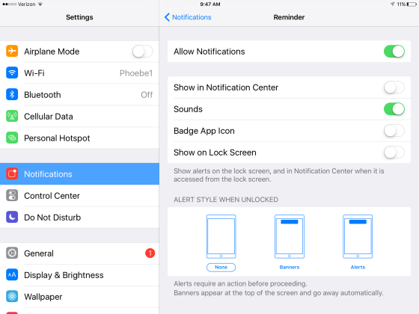
ONCE DONE GO INTO SETTINGS AND NOTIFICATIONS AND CHOOSE HOW TO BE “NOTIFIED” WE DO SOUNDS ONLY.
- GREAT support… I email developer and he responds within 24 hours!
Don’t be afraid of Settings in apps … Make Settings your friend!!

Important information to maximize use of purchased Reminder App’s!!!!!!!!
http://www.aidaorganizer.com/mac/index.html
support@aidaorganizer.com
FYI!!!!!!!
This Reminder App and all of the apps that use notifications have just a bit of a quirk - Apple has set a limit of 64 “notifications” to be played on any app before the app must be “opened “and reset so to speak.
When you are using “sounds” only for notification/reminders …. Keep this in mind for maximum success!!!
What this means is once the 64 reminders go off - to have the next programmed one’s play, the app must be touched on the home screen to open it…even if it is running in the background (double tap home button to see apps running in background).
This will “reset” it and 64 reminders/notifications will go off again before it needs to be touched and opened. Once reset, you can resume work on any other apps that you utilize and know that the reminders will go off in the background.
I have a notification/reminder that goes off at 8:00 am and 6:00 pm to remind Kara to just go to “Paddy” and touch the app. Kara has over 70 “voice prompts” to guide her through her day so we need to “reset” more than once during day.
If you are working with the “alert” style of notifications you may utilize this
On iPad…With the Reminders app (Calendar icon), you can swipe from right to left on the notification, tap View and tap Done. The app will reschedule 64 notifications. Tapping the Done button (or Snooze button) will open the app in the background and close it after a few seconds. The app has enough time to reschedule another 64 notifications.
On iPhone…notification alert may be at top of screen or in middle of screen - you will hear the voice reminder, tap the alert and the app will open and reset
A work around … beg, borrow or get on eBay an old iPhone or iPod touch capable of running iOS9 Load Aida reminder or Reminder and the voice reminders you want to utilize.
Plug the device in to power, set “auto-lock” in settings to NEVER and keep the Reminder app of choice the only app running. With this configuration you do not need to “reset” the reminders. They will continue to go off. You can connect a speaker to it as well for maximum sound
For Reminder App IF ANY ISSUES OR QUESTIONS EMAIL THIS DEVELOPER!!!! support@aidaorganizer.com

Our favorite Step by Step Picture and Audio Prompting App
Pictello! Available on in Apple App Store and Google Play!!!
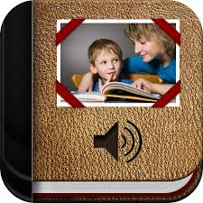$19.99 Our Task Maker and Cooking App

Create Categories depending on individual... could be a home task, a vocational skill or recipes! Great for a school activity or home health care!!!
We break down Kara’s cooking even further to Microwave or Crockpot and then add her recipes underneath

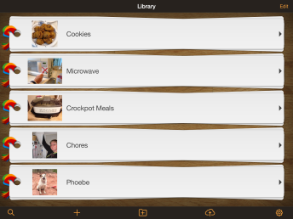
Create a Category/Folder

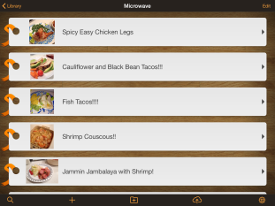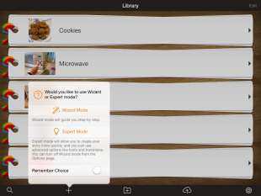
Add Recipes/Tasks Make new Folders/Activities Wizard!!!!
- Utilize pictures, video, a person’s own voice or Pictello voice for step by step!! Many “voices” to choose from!
- The app will walk you through exactly what you need to do to create!!! Looks complicated at first… but once you go through once you’ve got it!!
- I take pictures and put in album ahead of time to pull into app…cook and take pictures and then create recipe for further use
- Easy to backup and save!!! Can create task on one device and send to another, store on Pictello, save to Dropbox, can email to another Pictello user! Or Air Drop from one iPad to another!
- VOCATIONAL instruction invaluable- can be used on any iDevice or Android product
- Detailed instructions for home health care can be created!!!!! How to assist with AFO…
- Or school needs!!
- Can turn off editing feature once created so the task cannot be changed by end user
- Can choose different modes for playback by end user
- Pictello offers great support when emailing developer and lots of resources to look at on internet and YouTube Just search Pictello and you will be able to pull up loads of info from how to save to Dropbox
More Thoughts on Sharing Pictello Creations
The Pictello developer has created a variety of ways to share the stories, tasks or recipes created from a “sharing server, email, DropBox and iTunes.
All of these are great… there is a challenge if you create a very large “story” and want to share or backup. Dropbox has a limit on size, as do emails and sharing servers. You can save to iTunes and move back and forth on devices that way – I have done this.
I have use Air-Drop too very successfully!!! However this means both the original device (iPad or iPhone) that the Pictello story was created on must be near the receiving device to transfer the “story” or task.
Technology is not perfect and you will run across “glitches” and head scratchers.....

I usually Google “how do I…?” or even watch YouTube videos and don’t forget that sometimes the very best thing to do is email the developer and describe the issue. I have had great success with doing this and have learned a lot!!!!!!
https://www.assistiveware.com/product/pictello check it out for great instructions!
Made by AssistiveWare… a great company who created Prolquo2Go communication app

Other considerations for independence and self-determination –
Siri can be good for hands free support and asking questions, sending emails, texts, calling, opening apps etc
Just ask “Siri…What can you do?” On Android Devices ask “Hey Google” for your questions

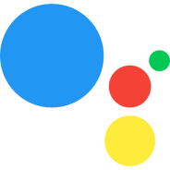

Or look at Google Assistant for Android products… from Google Play store or some of your devices may have already. If you have to add as an App you would need to open the app to ask questions but it is a great app….link to a Google Calendar to set up hands free calendar management!!!

Socialization
Facetime Skype Amazon Alexa with Drop- In Feature Google Home
Super easy to customize an individual’s device for “favorites” for ease of use for socialization

Leisure time
Multiple apps…Google person’s area of interest to get ideas – “best apps for…”
- We have guitar apps, piano apps, art apps, sight word apps, and many more….delete if they do not work and find more
- No need to spend a lot of money on apps… start with free or “lite” versions - Upgrade if they work
- Free apps tend to have a lot of ads…can be frustrating to end user

Hints and tidbits to customize
- Depending on end user… may want to simplify the main Homescreen by moving infrequently used Apps into a folder and move them to another page.
- You can utilize up to 11”Homescreens” and move apps around. (Hold finger on app until it starts to wiggle, keep finger on app and move to where you want it, touch “home” button to stop wiggling)
- Delete unused apps ( same as moving app…when app wiggles there is an x in upper left corner, touch that to delete) Can always bring them back from the Cloud if you want them back. Not all apps can be deleted…native apps are designed to stay on your device
- Get familiar with built in accessibility features too!!! More and more capabilities to really customize an iPad for many needs!!
- Guided access can be helpful for using just one app
- Voice Over feature or Screen Reader feature is offered in many apps for Android and Apple
Smart Speakers…the future is now!!!!

Alexa and now Google Home…… Voice Activated Speakers!
Three things needed!

- Amazon Echo Device or Google Home with Amazon or Google Account
- Wi-Fi
- Smart phone /tablet & Amazon Alexa App or Google Home App

To set up and customize …to have an Amazon account or Google Home, you do need an email account

Built in Features-
“To Do lists” Shopping List Daily Reminders (Echo better)
Timers and Alarms Link Calendars for voice control
Hands free calling and messaging and with all of the devices and with Amazon Echo Show and Smart Phone Drop-In feature for video connection!
1 .Add “Skills”…..from Amazon Alexa App and “services” from Google Home and chose the wake word to use!
2. Add Smart plugs or other smart home devices and “Link” Smart Home Skills – voice control of many aspects of independent living
3. Amazing capabilities- Reading books, listening to music, positive affirmations, stress reduction, games, and jokes, unlimited and growing!

Then…..Smart Home Control... by voice!

The next step is to add smart plugs, Hubs if need be and smart lights or whatever set up you choose to allow for a voice controlled home from turning on television, managing heat, turning lights on and off… more and more added all the time!

All the sites I have researched in comparing the two recommend Echo Devices for better Smart Home control options - in the end it will come down to your personal preference and budget.
Which one?????

Many similarities …some swear by Google Home, others by Alexa. Google Home does not have screen capability yet like Echo Show but it is coming. Instead of “skills” Utilizes “services” and Google home will have many similar things to Amazon Echo “Skills”

Google Home is easier set up and the Google Home App is less complex too
For starters, there’s nothing to install or enable. On the Amazon Echo, you have to activate the “skills” you want to use, but with Google Home, many are turned on by default. If your Home is set up, you can start talking to any of these services immediately with the “Hey Google” or “OK Google”
To maximize use I recommend adding Google Assistant App too...Adds visuals for many of the ‘services’

https://assistant.google.com/explore/

This app can be added to a Smart Phone or Tablet and is WAY better than Siri. You do need to open the App to use on iPad

Other Options… Apple Home Pod - price point of $349.00!!!

Have Fun!!! Feel free to contact me!! Technology will transform lives!
Become a champion!!!

Families at the Forefront of Technology http://www.familiesforefront.org/
Alice Brouhard RN and
MOM (Master of Modifications) !!! techable2@gmail.com
(970) 404-7303

Learning Lab 2018
Before purchase Android Products…know which OS (Operating system) your device will have when you purchase. Would recommend Marshamllow or Nougat as some of the newer apps may not run on older OS’s
Resources and Recommendations for Android/Google Play
Google Home App must have to use Google Home

Google Assistant…. Can install on iPad, iPhone as voice assistant. You do have to open the app to use it. We like it way better than SIRI and gives nice visuals too!!
The Google Assistant app provides another way to launch the Assistant that is available on an android phone. It allows you to quickly access your Google Assistant with one tap. You can still access your Assistant on android by pressing and holding down your home button or by simply saying, "Hey Google."

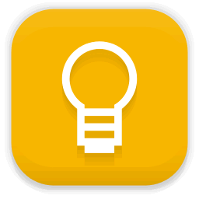 Google Keep works on phones, tablets and can add to PC/Mac and it wil sync across all devices!!!

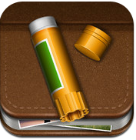 Story Creator App
Story Creator - Easy Story Book Maker for Kids 4+

Innovative Mobile Apps

Love this app too !!! and can email or post completed books on Facebook Apple store- was free, may be very low cost now

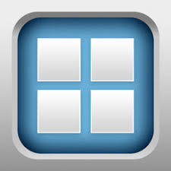

Bitsboard Flashcards & Games

Includes 25+ Learning Games

Happy Moose Apps
Great App – very low cost in Apple App store ….a “Pro” version in Google Play and more $$$
Not “babyish” and good cognitive exercises!!! I enjoy them too!

GREAT RESOURCE!!!!!!!!
Just Google …..CALLScotland you will then be able to go into all of these areas!!
http://www.callscotland.org.uk/home/ then
http://www.callscotland.org.uk/downloads/posters-and-leaflets/
http://www.callscotland.org.uk/common-assets/cm-files/posters/android-apps-for-learners-with-dyslexia.pdf

If you bring up the last link you will gain access to this great poster (on next page) that has a multitude of Android Apps for learners with dyslexia…many will work for a variety of needs.
There are “wheels of apps” as well for Apple’s iOS Apps- I just attached and added this to show the variety available for Android
See attached wheel for list of apps ….remember when you access online just click on the app and it will take you into the Google Play store

Amazon Alexa
So many skills!!!
Great for day to day orientation… just use your voice!
“Alexa or Echo”
What day is it What time is it
What am I doing today What am I doing today
Set a timer for … What is the weather
Tell me a joke
What is my Flash News briefing
Remind me every day at 8:00 am to take my meds
Give me a recipe for banana bread
Wikepedia are dogs eaten in Vietnam
Play Adelle on Pandora

Cool feature if you have more than one Alexa… can use as an intercom system within your house “Alexa announce to Jim that dinner is ready”

Great skill called “Ask My Buddy” (on Google Home too) – enable, create user account on “Ask My Buddy” website and then add list of contacts to notify if you need help. Provides a text, email and landline notification that you need help…and it is darn quick!! Nominal fee now

“Blueprints” now to create your own sets of skills “Alexa what do I need to get ready for work” could be a skill set! You customize to your needs

Smart home setup… so much info on web, YouTube videos and at Amazon site

LOVE ECHO SHOW!!!! Drop in and for much more!!

Google Home….many of the same things
“Hey Google or OK Google”
What day is it
What time is it
What am I doing today
…….limitless

Reminders and timers not as good as far as telling you what the reminder or timer is for…but not to say it will not happen in the future
and no “Blueprints” to build your own skills yet
Smart home set up too!

Just take your time, it is process, make it fun to start and don’t be afraid to add new skills…for us - the fewer words the better to ask for a skill and we have a cheat sheet index card right by Alexa as we sometimes can’t remember the right words to activate skill
New things are being added all the time and it is fun to see and learn about what is next!!

Both allow for phone calls to contacts or to places “Alexa or Hey Google”…. call my Mom or call King Soopers -
At this point cannot work your way thorugh a telephone tree has to be a direct call . Meaning you can’t say “ press 1 or press 2….”
More Recommended Apps
Start slow…. Master one app at a time or you will get overwhelmed!
Note-taking and Learning Apps
Picture Scheduler
- https://itunes.apple.com/us/app/picture-scheduler/id315050461?mt=8
- App is helpful people who rely on visual and auditory supports to do their common tasks easily.
- Picture of each task is represented with audio, video, or picture
- Each task can be attached to a timer.
- Only for Apple
- Cost - $2.99
Canplan
- http://www.canassist.ca/
- For any given task, a user initially goes through the activity with a support person, taking photos of each step in the task, adding text or audio as needed.
- File task under a customizable set of categories.
- Option of audible timed reminders
- Active Task Reminder: helps the user stick with a task until it’s complete
- Only available for Apple Products
- Cost- Free

Evernote
- https://evernote.com/
- Write notes of all types, from short lists to lengthy research, and access them on any device.
- Collect web articles, handwritten notes, and photos to keep all the details in one place
- Regular app – free, Evernote Premium $5.99/month

Prizmo
- http://www.creaceed.com/iprizmo/about
- Universal photo-based scanner app that lets you scan and recognize text documents, business cards, and images, and then export them as PDF/Text, vCard, or JPEG/PNG.
- Image cleanup ability.
- Using iCloud, you can even shoot the picture on your iPhone, and finish editing on your iPad or Mac.
- Text can be spoken via Voice Over feature.
- Only available for Apple
- Cost - $9.99

SnapType
- https://itunes.apple.com/us/app/snaptype-for-occupational/id866842989?mt=8
- App allows user to take a photo of the document and add text type text.
- Can organize documents into folders (i.e. – by subject, due date, etc)
- Users can upload documents to access elsewhere.
- Available only for Apple
- Price – Free - $3.99

MyScript
- http://www.myscript.com/
- Turns handwritten words into interactive text, making it easy to edit, search, and take action on your notes.
- Words and sentences can be quickly moved, split, joined, and erased by simple gestures.
- You can easily interact with words you have written (i.e. see the word definition, search in a dictionary, Wikipedia®, or Google®; send a page or notebook to a contact name in your address book).
- Cost- Free

Ghotit
- http://www.ghotit.com/
- Specifically created for individuals with Dyslexia and/or Dysgraphia
- Helps with writing, correcting, and proofreading texts.
- Corrects misspelled and confused words, grammar, and punctuation errors and provides in-context word prediction with grammar and phonetics awareness capabilities.
- Speak as you write ability
- Only available for Apple products
- Cost-$49.99

Voice Dream Writer
- http://www.voicedream.com/
- Text-to-speech proofreading reduces mistakes – reads writing aloud so user can easily spot mistakes or structuring issues
- phonetic and meaning search help you use the right words – use attempts at spelling or phrases to find the word that was meant to be included
- helps you organize and improve the structure of your writing
- Only available for Apple products
- Cost- $9.99

Audionote
- http://luminantsoftware.com/iphone/audionote.html
- Combines the functionality of note-taking and voice recording apps to create a powerful tool that saves time and improves the quality of notes
- automatically indexes your meetings, lectures, classes, interviews, etc
- Cost – free - $4.99

Memory Apps
Alarmed ~ Reminders + Timers
- http://yoctoville.com/alarmed-app-details
- Pop-up reminder alerts with repeat scheduling, flexible snooze and full customization
- Pop-up timers with custom messages, countdown / countup and pause
- Over 80 high-quality custom sounds included
- Available only on Apple products.
- Cost-Free

TextGrabber + Translator
- http://www.abbyy.com/textgrabber/
- Quickly scans, translates and saves your chosen text from virtually any printed material.
- Text can be spoken aloud using and translated via Voice Over feature.
- Adjustable font sizes and audio prompts to also help with vision impairments.
- All extracted text is automatically backed up and can be easily found in the “History” folder
- $4.99

Aida Reminder
- http://www.aidaorganizer.com/mac/index.html
- Create recurring or one-time reminders easily and quickly.
- Easy to control reminders settings
- Only available on apple products.
- Cost - $0.99

ScreenChomp
- https://www.techsmith.com/screenchomp.html
- Supervisors / staff can use this to aid in additional training for employees
- Touch RECORD to capture touch interactions and audio instructions on a plain background, or an image from your iPad camera roll.
- SKETCH out ideas and talk the viewer through the "how" and "why" of it all.
- SHARE video to ScreenChomp.com to generate a simple web link you can paste anywhere or download on mpeg.
- Only for Apple Products
- Cost – Free

Concentration Apps
Relax Melodies
- http://www.ipnossoft.com/
- Select sounds and melodies that you like and combine them to create a mix. Adjust the volume of each sound individually for better results.
- Considered a sleep aid App but is also good for relaxation and concentration
- Use timers and alarms to end sounds if needed.
- Aids to a better night’s rest which also aids to a decrease of anxiety and low moods
- Cost – Free

Canplan
- http://www.canassist.ca/
- For any given task, a user initially goes through the activity with a support person, taking photos of each step in the task, adding text or audio as needed.
- File task under a customizable set of categories.
- Option of audible timed reminders
- Active Task Reminder: helps the user stick with a task until it’s complete
- Cost- Free for Apple, $3 for Android

Anxiety Apps

Equanimity - Meditation Timer & Tracker
- https://itunes.apple.com/us/app/equanimity-meditation-timer/id351825794?mt=8
- Time each session and watch for visual light cues to let you know how long you’ve been meditating. Take notes about each session, and watch your progress as you learn to manage your stress and anxiety.
- Compatible with iPhone, iPad, and iPod touch
- Cost - $4.99

Worry Watch
- http://worrywatch.com/
- journal app designed specifically to log worries & self-realizations and track them visually.
- By logging and tracking ‘what might happen’ perception to ‘what did happen’ reality, the hope is to get a deeper understanding of our worry patterns
- Cost - $1.99

Relax Melodies
- http://www.ipnossoft.com/
- Select sounds and melodies that you like and combine them to create a mix. Adjust the volume of each sound individually for better results.
- Considered a sleep aid App but is also good for relaxation and concentration
- Use timers and alarms to end sounds if needed.
- Aids to a better night’s rest which also aids to a decrease of anxiety and low moods
- Cost – Free

Breathe2Relax
- http://t2health.dcoe.mil/
- App provides detailed information on the effects of stress on the body
- Instructions and practice exercises helps users learn the stress management skill called diaphragmatic breathing.
- Breathing exercises have been documented to decrease the body’s ‘fight-or-flight’ (stress) response, and help with mood stabilization, anger control, and anxiety management
- Cost – free

Relax & Rest Guided Meditations
- http://www.meditationoasis.com/smartphone-apps/iphone-application-support/
- Three meditations of varying lengths allow you to relax deeply. Written Meditation Tips help support the experience of guided meditations.
- Each meditation can be listened to with or without music or nature sounds, and you can choose how long to listen to the music or nature sounds after the guided meditation finishes. Separate volume controls allow adjusting the mix of voice and sounds to suit your preference
- No previous meditation experience is required.
- Cost - $1.99

Self-Help for Anxiety Management (SAM)
- http://sam-app.org.uk/
- Tell the app how you’re feeling, how anxious you are, or how worried you are. Then the app’s self-help features will walk through some calming or relaxation practices.
- Cost-Free

Just Google for many others….

Training Apps
ScreenChomp
- https://www.techsmith.com/screenchomp.html
- Supervisors / staff can use this to aid in additional training for employees
- Touch RECORD to capture touch interactions and audio instructions on a plain background, or an image from your iPad camera roll.
- SKETCH out ideas and talk the viewer through the "how" and "why" of it all.
- SHARE video to ScreenChomp.com to generate a simple web link you can paste anywhere or download on mpeg.
- Only for Apple Products Cost – Free
Canplan
- http://www.canassist.ca/
- For any given task, a user initially goes through the activity with a support person, taking photos of each step in the task, adding text or audio as needed.
- File task under a customizable set of categories.
- Option of audible timed reminders
- Active Task Reminder: helps the user stick with a task until it’s complete
- Cost- Free for Apple, $3 for Android

