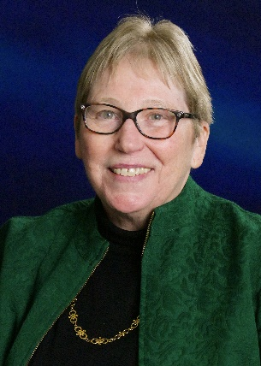
CORDELIA.ROSENBERG@CUANSCHUTZ.EDU
Cordelia Robinson Rosenberg is Professor of Pediatrics and Psychiatry, University of Colorado School of Medicine. From 1993 through June of 2015. Dr. Robinson Rosenberg was Director of JFK Partners, an interdepartmental program of Pediatrics and Psychiatry at the CU School of Medicine. In this role she was responsible for providing leadership, direction to an interdisciplinary professional staff of over 40 faculty members. She has worked in the field of early intervention for children with developmental disabilities as a clinician, researcher and educator of personnel from multiple disciplines since 1973. She has been the PI on over 40 federally funded demonstration, training or research projects in the field of Developmental Disabilities and Intellectual Disabilities. Work since 2001 has been focused on Autism Spectrum Disorders. She is Co-Principal Investigator on the CDCP funded Colorado CADDRE and Surveillance projects. She is PI on the Colorado site of the SPARK study. She Co-chairs Colorado CANDO (Colorado Autism and Neurodevelopmental Disorders Options) an ad-hoc committee pf the Colorado Developmental Disabilities Council. CANDO meets quarterly offering educational opportunities in follow up to the Colorado Autism Commission. She also serves as the evaluator for Colorado Inclusive Higher Education Pilot Program. Most recently she has joined Colorado’s Employment First Action Partnership and looks forward to providing Direction to The Colorado Office of Employment First through an Interagency Agreement for funding from the Colorado Division of Vocational Rehabilitation, Colorado Department of Labor and Employment.

