David Monroe
Director of Legal Services
David Monroe joined Disability Law Colorado as the Grand Junction Office Managing Attorney in January 2017 and was named Director of Legal Services in April 2021. He graduated from the University of Colorado-Boulder in 1988 with a degree in history and obtained his law degree from CU in 1992. David began his career in law as criminal defense attorney in private practice back in 1992. Over the past 25 years he has worked as an educator, educational and grant administrator and as executive director of a non-profit agency providing services to people with disabilities, as well as continuing in the practice of law. In his role as managing attorney of the Grand Junction office he represents individuals with workplace and housing discrimination issues as well as students and parents with disability-related legal issues in schools. dmonroe@disabilitylawco.org
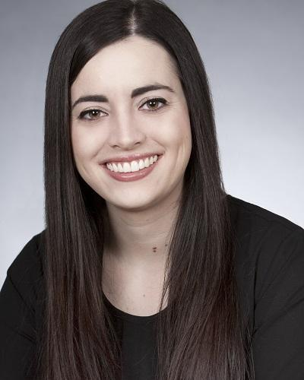

Olivia Pilcher
Rights Advocate
Olivia Pilcher is a Rights Advocate in Disability Law Colorado's Grand Junction office. She joined Disability Law Colorado in May 2017. Prior to joining Disability Law Colorado, she worked in various capacities in the mental health and substance abuse field, for the Department of Human Services, and for the Arizona House of Representatives. Olivia has a bachelor’s degree in political science and international affairs from Northern Arizona University and a master’s degree in social work from the University of Denver. opilcher@disabilitylawco.org
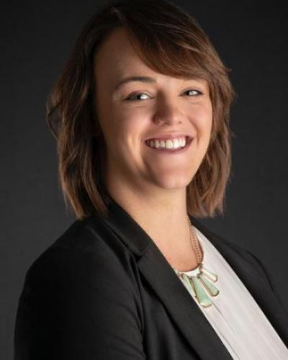

Sara Pielsticker
Staff Attorney
Sara Pielsticker joined Disability Law Colorado as a Staff Attorney in 2021. She graduated from the University of San Diego in 2016 with a degree in Education and Nonprofit Management and from Syracuse University in 2020 with a dual degree. She received her law degree from the Syracuse University College of Law with a curricular focus in Disability Law and Policy and a Master’s of Science in the Cultural Foundations of Education with a Certificate of Advanced Study in Disability Studies. Sara is originally from Colorado and has spent most of her life working for nonprofits that promote inclusion for people with disabilities. In her free time, she enjoys photography, jigsaw puzzles, and being outdoors as much as possible. spielsticker@disabilitylawco.org

