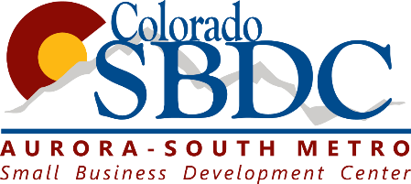
Questions & Answers from OEDIT on Disaster Loan Programs (04 06 20):
- If I am applying for / received an Economic Injury Disaster Loan, is my small business eligible to participate in the Paycheck Protection Program?
Borrowers can apply for both an SBA Economic Injury Disaster Loan and the Paycheck Protection Program loan. However, the Paycheck Protection Program loan funds and the Economic Injury Disaster Loan funds cannot be used for the same purpose. The Paycheck Protection Program loan must be used for payroll (minimum of 75% of the funds received) for it to be eligible for a forgivable loan and the remaining is used for different purposes. Borrowers who accept both loan funds should document the uses of the funds appropriately.

- Received EIDL – Apply for PPP: Yes, you are still eligible to apply for the Paycheck Protection Program even if you applied for or received an SBA Economic Injury Disaster Loan.
If your Economic Injury Disaster Loan was not used for payroll costs, it does not affect your eligibility for a Paycheck Protection Program loan.
If your Economic Injury Disaster Loan was used for payroll costs, your Paycheck Protection Program loan must be used to refinance your Economic Injury Disaster Loan. The Paycheck Protection Program’s maximum loan amount is $10 million with a fixed 1% interest rate and maturity of two years. Economic Injury Disaster Loan assistance provides up to $2 million loan per business and are long-term, low-interest rate at 3.75% for businesses and 2.75% for non-profits and a maturity of up to 30 years
Any advance up to $10,000 on the Economic Injury Disaster Loan will be deducted from the loan forgiveness amount of the Paycheck Protection Program loan.

For example, a borrower may obtain a loan from the Paycheck Protection Program and use those funds to pay for 8 weeks of payroll or employee retention. They may wish to then dedicate their entire EIDL funds towards working capital, notes payable and accounts payable that do not duplicate the funds provided through the Paycheck Protection Program. If the EIDL loan was used for payroll expenses, the borrower must refinance the EIDL loan with the PPP loan which carries a lower interest rate as well as a shorter maturity period.

- Do I have to choose one or the other?
Select the loan program that best meets your individual business needs; however, you are not permitted to hold funds from both programs for the same purpose.
The PPP loan has different terms from the EIDL loan. The Paycheck Protection Program’s maximum loan amount is $10 million with a fixed 1% interest rate and maturity of two years.
Economic Injury Disaster Loan assistance provides up to $2 million loan per business and are long-term, low-interest rate at 3.75% for businesses and 2.75% for non-profits and a maturity of up to 30 years
The application period for PPP loans runs through June 30, 2020, but the EIDL application period runs through December 2020. If you have working capital need beyond what is provided by PPP, you can apply for additional assistance through the EIDL program.

If you are applying for both, you can accept PPP first – then decide whether to close on your EIDL approved loan. An EIDL approved loan may be closed within 60 days, and the borrower can choose whether to close on the loan. The EIDL application period runs through Dec. 2020.

